I. Introduction

Water quality is an important aspect of the health and well-being of human society and aquatic ecosystems [1] , [2]. Poor water quality of lakes can lead to the degradation of aquatic habitats, the decline of aquatic species, and the spread of waterborne diseases which will affect human society.

Monitoring water quality of lakes is essential for a variety of reasons. Lakes are a vital resource for human society, agriculture, and industries. Ensuring that the lake water is safe and suitable for human use is critical for maintaining public health and important for sustaining economic development.

Lakes are ecosystems that support diverse aquatic life, from fish and algae to microorganisms. Any change in water quality can have significant impacts on the survival of these aquatic organisms, which can, in turn, affect the overall ecological health of the lake.

Lakes are sensitive to human activities and environmental changes such as Climate change, pollution, land-use changes, and other human impacts can all affect the water quality of lakes. Regular monitoring of water quality is therefore crucial for identifying and mitigating these impacts, and for maintaining the long-term health and sustainability of lake ecosystems.

Monitoring water quality of lakes is essential and important for supporting aquatic life, protecting human health, ensuring recreational opportunities, and preserving the ecological health of lake ecosystems.

In this paper work we have discussed about our project where we are focusing on monitoring and forecasting of water quality of lake through various techniques. First, Onsite-Measurement Technique by Image Processing which will provide the real time estimation of water quality, also Forecasting of lake water quality by training with the historical monitored data. Second, Remote Sensing via. Sentinel 2 satellite for estimation of quality of n-number of lakes simultaneously. And a full flexible website for accessing the monitored and forecasted data.

* 1. Onsite Measurement

Onsite measurement of water quality of lakes is a crucial and important aspect of water quality monitoring. Traditional methods of onsite measurement involve taking water samples and analyzing them in a laboratory. However, these methods are time-consuming, expensive, and labor intensive, and may not provide real-time data on water quality of lakes.

Image processing techniques can be used to improve the efficiency and accuracy of water quality measuring factors. Image processing involves capturing the images and applying the specific algorithm to process the captured image which will be further discussed in the section of image processing.

Similarly, For forecasting of water quality via. Historical data of water quality we have tried numerous Machine Learning algorithm which we have discussed in further Machine Learning section.

Design and develop a real-time water quality monitoring system based on parameters such as pH, turbidity, Total Dissolved Solids (TDS), temperature.

* 1. Remote Sensing

Remote sensing technology is a useful tool for monitoring turbidity levels and chlorophyll in water bodies.

Remote Sensing is a powerful tool for monitoring water quality of many lakes simultaneously. Through the satellite Sentinel-2 we expect to achieve a decent analysis of water quality of more than one lake simultaneously.

Sentinel-2 is a wide-swath, high-resolution, multi-spectral imaging mission supporting Copernicus Land Monitoring studies, including the monitoring of vegetation, soil and water cover, as well as observation of inland waterways and coastal areas.

In this project we are going forward with Google Earth Engine (GEE) as a platform for monitoring via. Sentinel-2 satellite.

* 1. Website

We have developed a website that focuses on water quality monitoring of lakes. This website is designed to provide real time information to its users about the water quality of lakes and help them stay informed about the quality of water.

The website features new modern technologies for water quality monitoring such as Remote Sensing, onsite image processing and Forecasting. These tools make

The websites user friendly interface gives the user the flexibility to easily navigate and access the various water quality information of various lakes.

II. PROPOSED METHODOLOGY

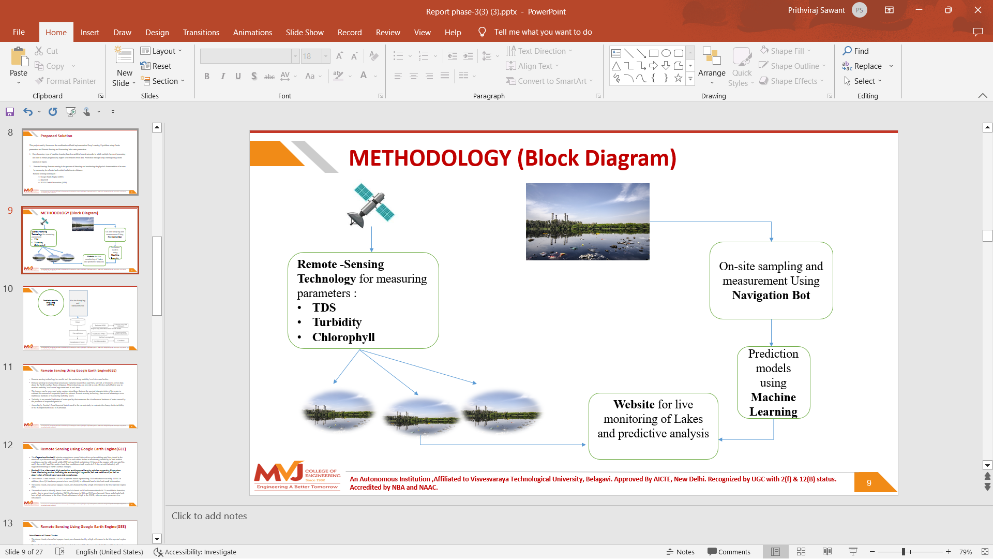

In this section, we present a brief [3] methodology on water quality monitoring of lakes.

The methodology is divided into two parts: One focuses on capturing images and gathering data via. onsite measurement and applying the Image Processing on the captured images and Machine Learning for forecasting on the gathered data.

The Second focuses on Remote Sensing Model for monitoring the numerous lakes simultaneously via. Satellite.

And finally integrating these data and information on the user-friendly website so the user can navigate and access with ease.

[1] “The water crisis,” https://water.org/our-impact/water-crisis/, accessed:

2018-09-30.

[2] “Keeping drinking-water safe in the Philippines, ”https://www.who.int/philippines, accessed: 2017-07-11

[3] De La Salle University, 2401 Taft Avenue 0922 Manila Philippines , “Data-driven IoT-based Water Quality Monitoring and Potability Classification System in Rural Areas” 23 October 2020